ESP Micro USB: NodeMcu ESP-32S Lua ESP-WROOM-32

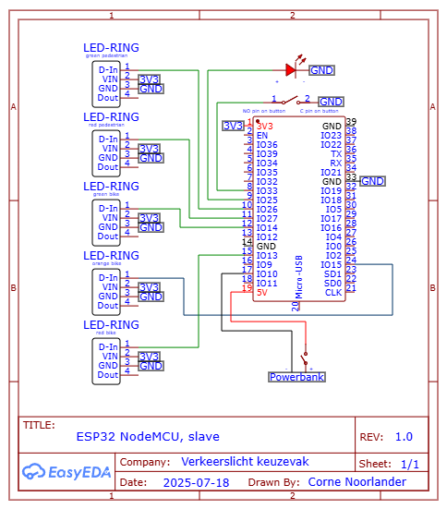

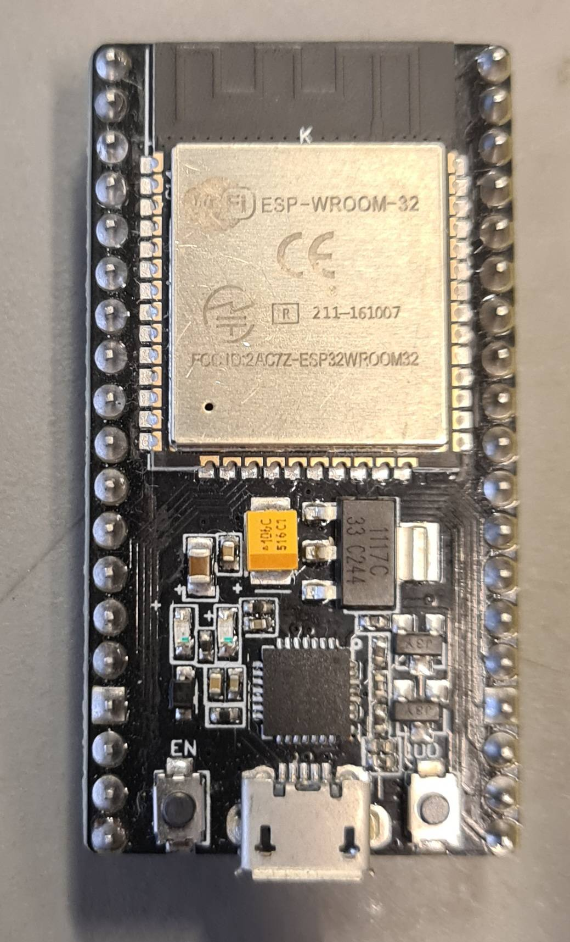

ESP Type C: Diymore ESP32 Nodemcu DevBoard

